1. Creating and Renaming Files/Directories.
- Create a directory named test_dir using mkdir.
- Inside test_dir, create an empty file called example.txt.
- Rename example.txt to renamed_example.txt using mv
Ans:
# Create a directory named test_dir
mkdir test_dir
# Move into the directory
cd test_dir
# Create an empty file called example.txt
touch example.txt
# Rename example.txt to renamed_example.txt
mv example.txt renamed_example.txt

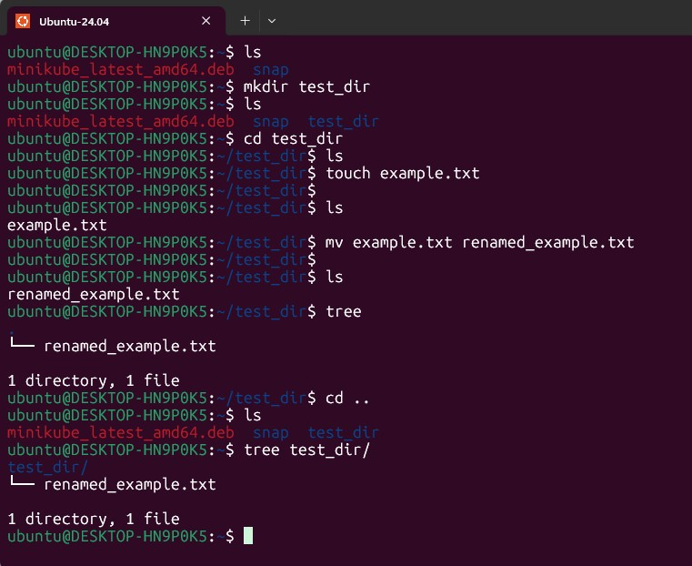
2. Viewing File Contents
- Use cat to display the contents of /etc/passwd.
- Display only the first 5 lines of /etc/passwd using head.
- Display only the last 5 lines of /etc/passwd using tail.
Ans:
# Display the full contents of /etc/passwd
cat /etc/passwd
# Display only the first 5 lines of /etc/passwd
head -n 5 /etc/passwd
# Display only the last 5 lines of /etc/passwd
tail -n 5 /etc/passwd
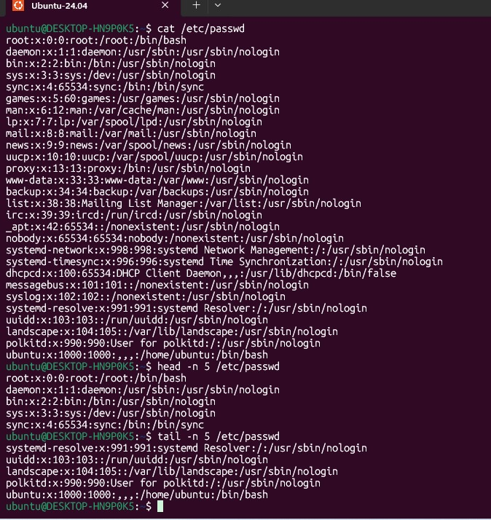

3.Searching for Patterns
- Use grep to find all lines containing the word "root" in /etc/passwd.
Ans:
grep "root" /etc/passwd
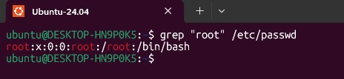
4. Zipping and Unzipping
- Compress the test_dir directory into a file named test_dir.zip using zip.
- Unzip test_dir.zip into a new directory named unzipped_dir.
Ans:
# Compress the test_dir directory into test_dir.zip
zip -r test_dir.zip test_dir
# Create a directory for extraction
mkdir unzipped_dir

# Unzip test_dir.zip into unzipped_dir
unzip test_dir.zip -d unzipped_dir
ls unzipped_dir
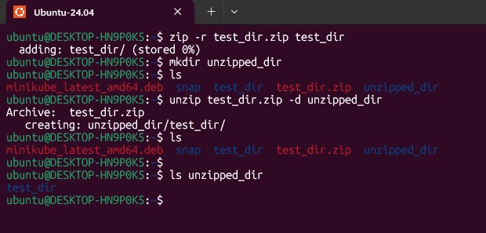

5. Downloading Files
- Use wget to download a file from a URL (e.g., https://example.com/sample.txt).
Ans:
wget ‐‐output-document=filename.html example.com
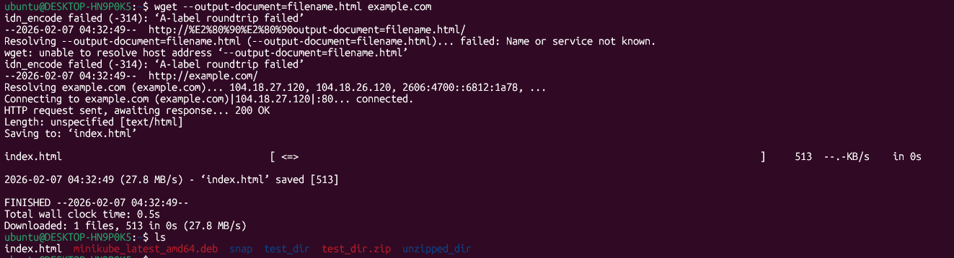
6. Changing Permissions
- Create a file named secure.txt and change its permissions to read-only for everyone using chmod.
Ans:
# Create the file
touch secure.txt
# Change permissions to read-only for everyone
chmod 444 secure.txt
ls -l secure.txt
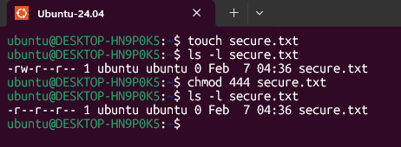
7. Working with Environment Variables
- Use export to set a new environment variable called MY_VAR with the value "Hello, Linux!".
Ans:
export MY_VAR="Hello, Linux!"
echo $MY_VAR

